EXECUTING THE ORACLE 10g SQL & OS-SIDE SCRIPTS (UNIX)

Important: The final responsibility for executing this script lies with the client.

- Scrutinize the contents of the script to ensure that it does not contain any statements, commands or any other code that might negatively influence their environment(s) in either a security or operational way.

- Test the script on the test environment to ensure that it does not contain any statements, commands or any other code that might negatively influence their environment(s) in either a security or operational way.

- The final responsibility for executing this script lies with the client.

- It is advised to execute the script during off-peak hours.

- The client must remove all copies of the script as it is the property of Ernst & Young LLP. The client may retain the script results.

Note: this assumes the database is version 10g running on Unix/Linux, and that the PC you are connecting from is running Microsoft Windows.

EXECUTING THE SQL SCRIPT:

(i) Telnet or (ii) SSH to the host server

Go to Start->Run
Enter “telnet host.ip.number.here”

i) Telnet: 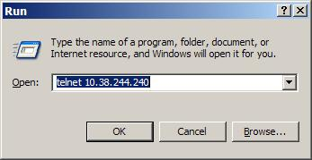

A command line screen will come up with the telnet session, asking for a login.
Use the oracle user (the DBA will know what it is). For this example the oracle user has been setup as “db12”.

ii) SSH: 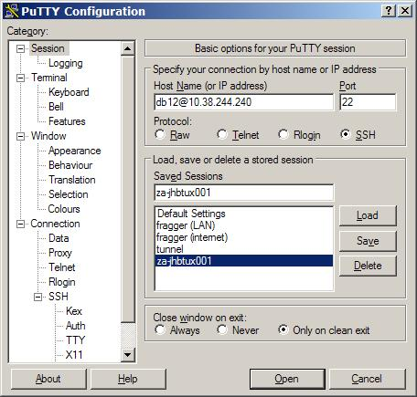

Once the oracle user and password have been entered a command line (indicated by a $) will be seen.

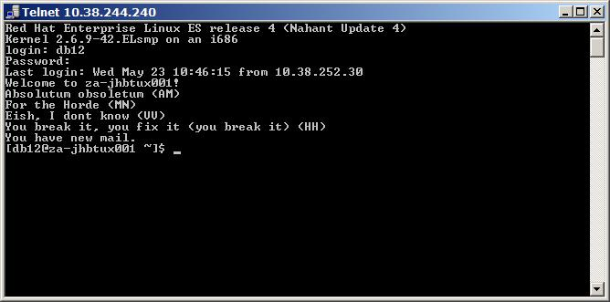

Change to the oracle home directory (cd $ORACLE_HOME) directory. This will take you to the directory where the Oracle database has been installed. If this environment variable has not been set, ask the DBA where it is located and manually change to that directory (using cd /directory_name).

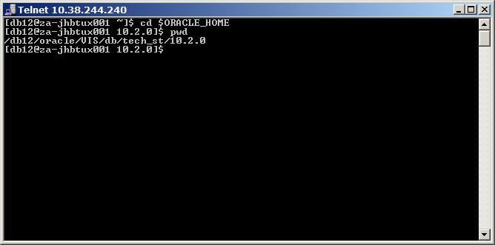

Create the audit directory by the following command: “mkdir audit”, and change to it by using “cd audit”.

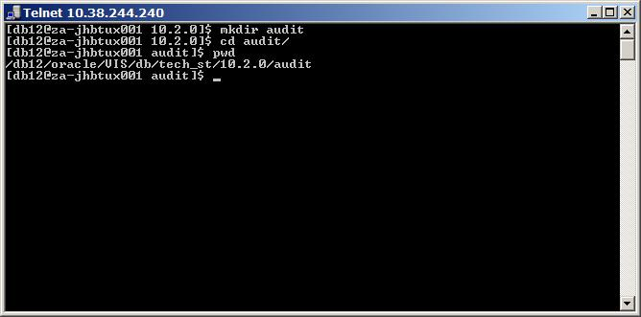

Place the script file in the directory. Ask the DBA or system administrator to do this. This can also be done via (i) via pscp (PuTTY’s secure copy) or (ii) ftp (Start->Run and enter “ftp”).

i) pscp: 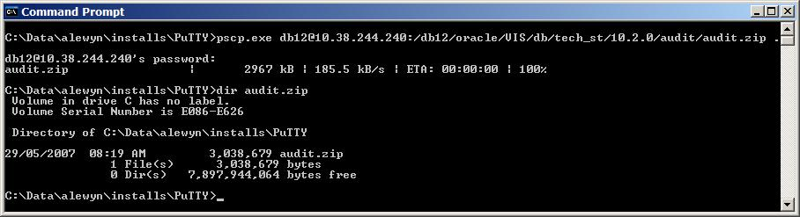

ii) ftp: 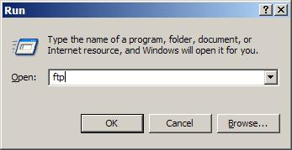

The following screenshot displays the commands required. It assumes the sql script is in the root drive directory (C:\).

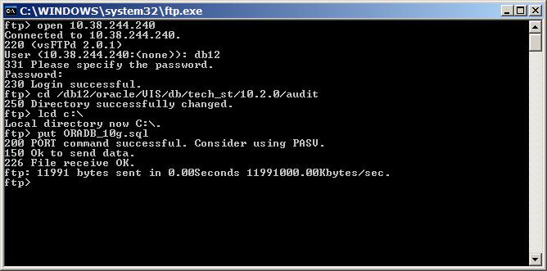

Change back to the telnet session. Ensure you are logged in as the oracle user, in the $ORACLE_HOME/audit directory (the ORADB.sql file should be here now).

Note: the permissions on the directory must be such that the oracle user can write to the audit directory. The DBA or System Administrator might have to change permissions by logging in as the root user and using the chmod command, as follows:

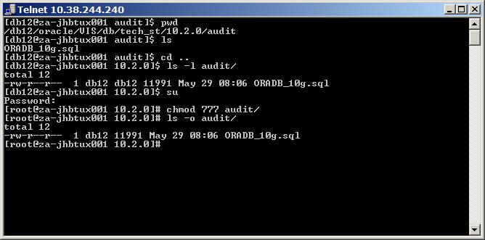

The list of files in the audit directory should only contain the ORADB_10g.sql file. Change the file permissions on the script to make it executable:

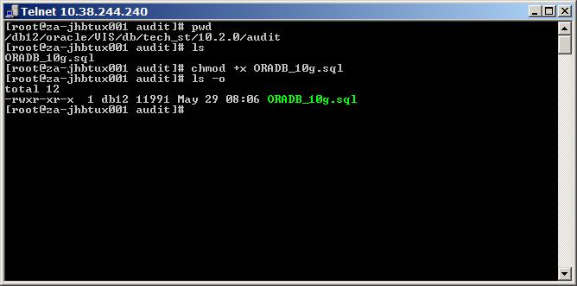

Start sqlplus. You might be able to login as the internal SYSDBA user, otherwise the oracle owner’s user name and password will be needed.

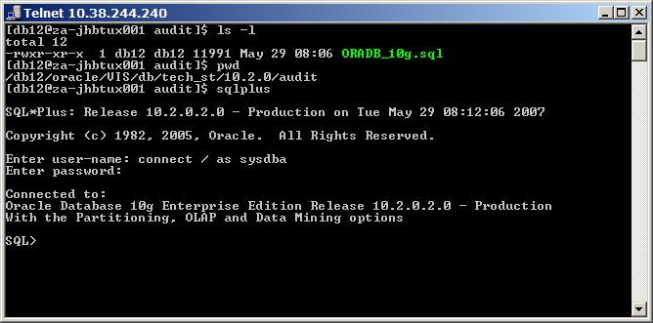

The SQL> prompt indicates that you are connected to SQLPLUS.

Start the ORADB_10g.sql file by executing the following command “start ORADB_10g.sql”. Providing you are in the audit folder, you can enter “.” as the response to the “Enter output file path ie. ../audit/ : “

The script will run. Verbose mode is set off (i.e. you will not see any screen output). It should not take more than 10 minutes to run. Ask the DBA to monitor the audit folder to ensure files are being created. Once completed the system will prompt you, as follows.

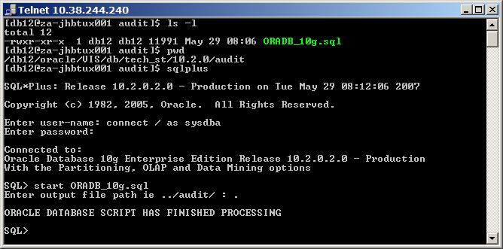

If it seems to be taking an unusually long time, it might be for the following reasons:

- File permissions are incorrect on the folder. Refer earlier description.
- Database is unusually busy (this should not be run during normal business hours).
- Hardware is inadequate (in particular where this is being run on a test / development box).

Next step is to type “exit” to quit the SQL environment.

Inspect the files by performing a “ls” or “ls -l”. See below.

ls: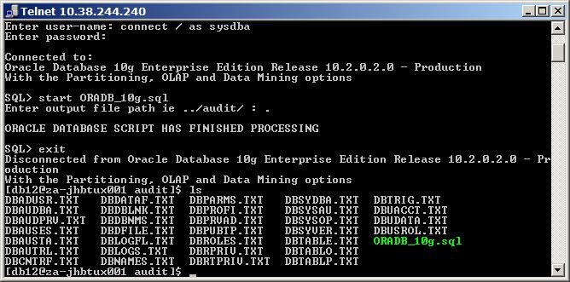

ls -l:
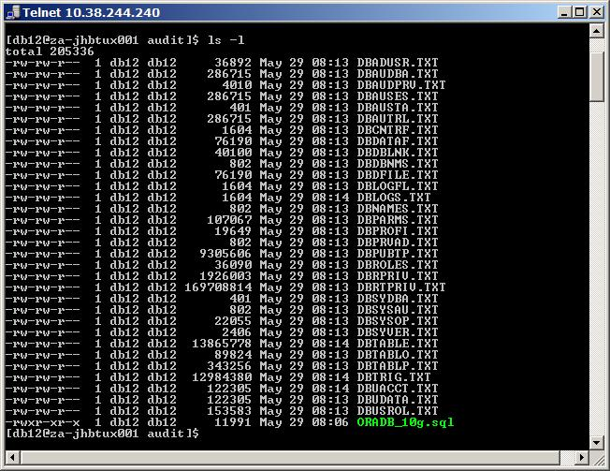

Lastly, you need to zip the files and ftp them back to your computer, as follows.
Zip the files, using Unix’s “zip” command (the -9 flag activates best compression):

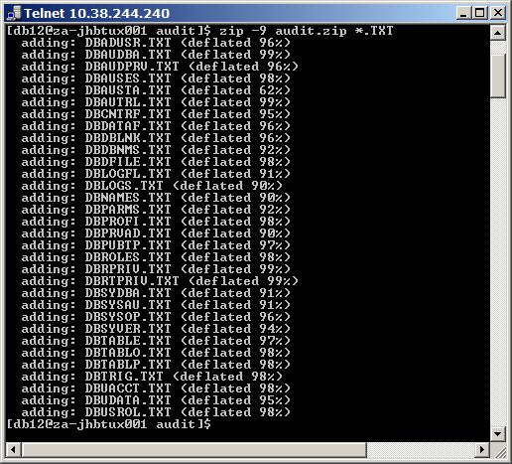

Go to the ftp session opened earlier.
Change to binary transfer mode (type “bin” and press the Enter key)
And copy the file back to your local folder (C:\ in the example below).

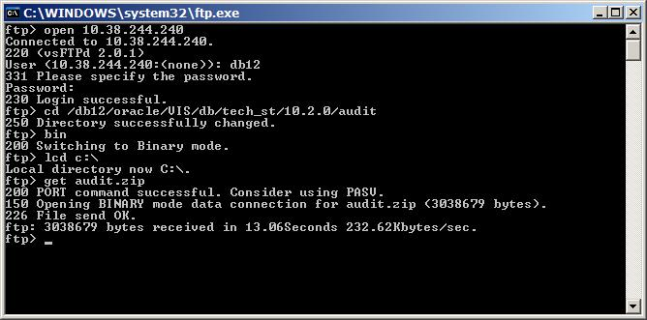

The audit.zip file will then be on your computer.

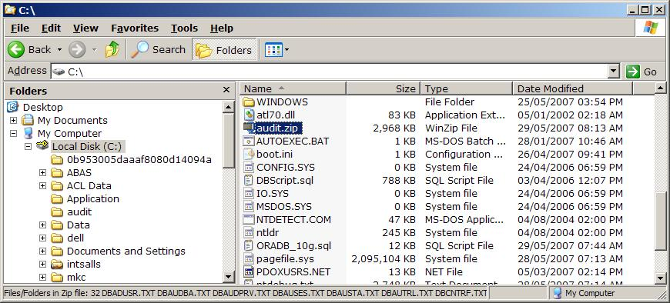

EXECUTING THE OS-SIDE SCRIPT:

- Connect to the server using telnet SSH, as demonstrated above.

- Copy the audit script (PwC_oracle_audit.sh) to the server via FTP or SCP.

- Change the file permissions on the script to make it executable: chmod +x PwC_oracle_audit.sh
- Execute the script by typing ./PwC_oracle_audit.sh in the directory containing the script.

(For script usage, type ./PwC_oracle_audit.sh -h in the directory containing the script)

- A .tar file, which can be extracted with Winzip, will be created under /tmp/PwC_oracle. Copy this file back to your local machine using FTP or SCP.

